# <https://wsvincent.com/python-pass-statement/>

# Python Pass Statement

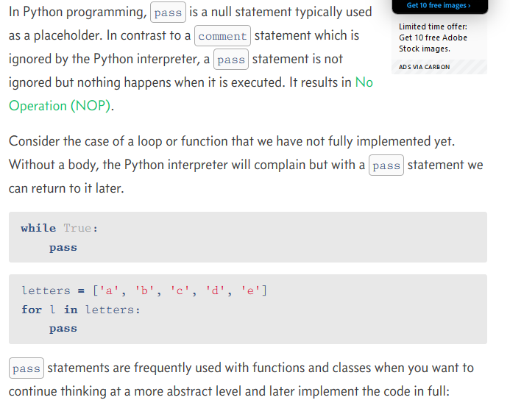

See the given three step of a example:

1.when not use pass/print

letters = ['a', 'b', 'c', 'd', 'e']

for i in letters:

    #pass

    #print(i)

Ans: show error

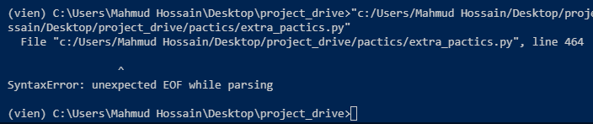

2.when use pass

letters = ['a', 'b', 'c', 'd', 'e']

for i in letters:

    pass

    #print(i)

Ans: show empty ans



3.when use print

letters = ['a', 'b', 'c', 'd', 'e']

for i in letters:

    #pass

    print(i)

ans: show output

a,b,c,d,e

more example of pass

